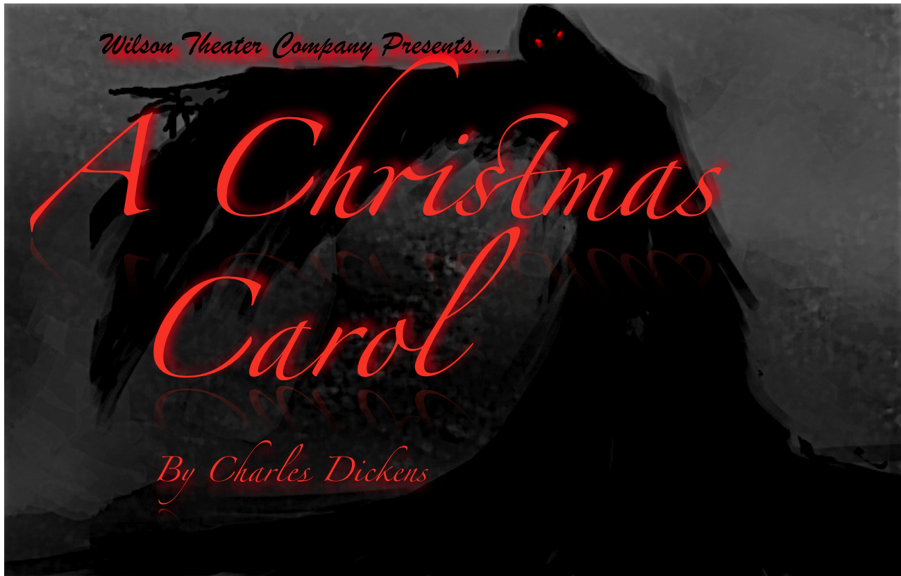
visit www.wilsontheater.org for details

November 19, 20, 21

