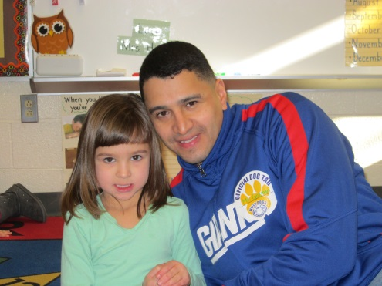
Dads: Be a Hero for A Day!
Be a Watch D.0.G.!

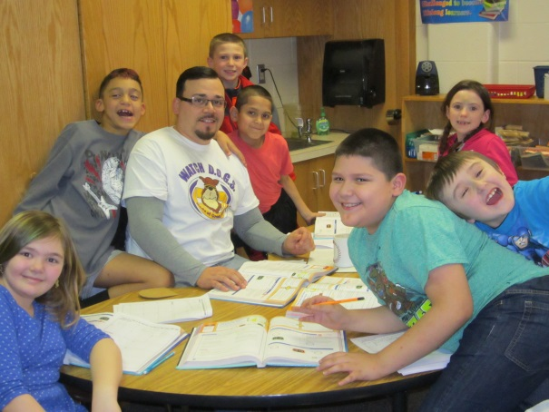
Watch D.O.G.S. Make a Difference
Dads of Great Students spend a day at school helping children in classrooms, with small groups and one-on-one. They do flashcards, read, listen, play games and more. They have lunch, specials and an academic class with their own children. Most of all, these dads connect with kids, letting them know by their very presence that the men in their community care about them and their education!

It’s Easy to Become a Watch D.O.G.
Simply email or call Ms. Laura Grant, School Counselor.
You’ll be given all the information and guidance you need to join this meaningful, powerful and fun school program!
GraLau@wilsonsd.org * (610) 670-0180, x3512
