Honors Biology Vocabulary List (Chapters 4-5)
Chapter 4:
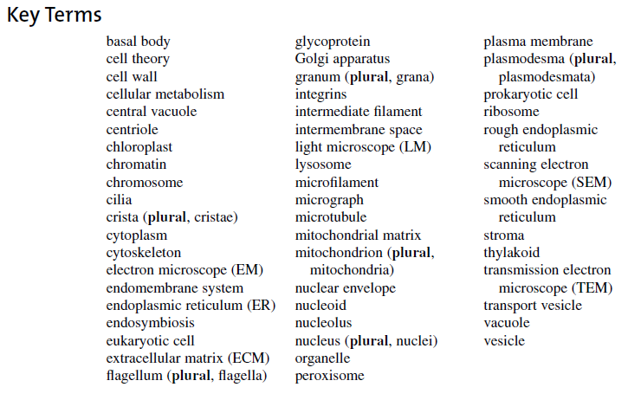
Chapter 5:
