Identification of an Unknown Mixture

The Challenge:

Your lab group must identify an unknown mixture that contains a combination of 2 of the 4 powders (A, B, C, and D)
?

Your Group Will Also Get:

- A sample of each of the four powders:
A
B
C
D

- Three solutions (I, II, and III) that will react with these four powders in specific ways
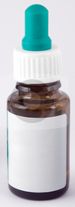
I
II
III

- A spot plate

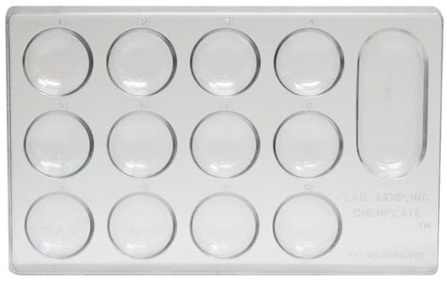

Pre-Lab Assignment:

Each of you should write a procedure for your group to follow. Your group should discuss each of your possible procedures before you begin.

Identification of Unknown

Unknown #: ________________________

Claim: “Unknown # ____ is a mixture of powders _____”

Evidence: “Data and observations are…” (Evidence should be appropriate, accurate and sufficient…In other words…Is it relevant, is it correct, and is there enough?)

Reasoning: “These data/observations support the claim because…” (Reasoning is an explanation of why the data counts in supporting the claim…How good is this data and why does it matter?)

