HONORS CHEMISTRY - UNIT 10 REVIEW

Examine the Phase Diagram for Water:

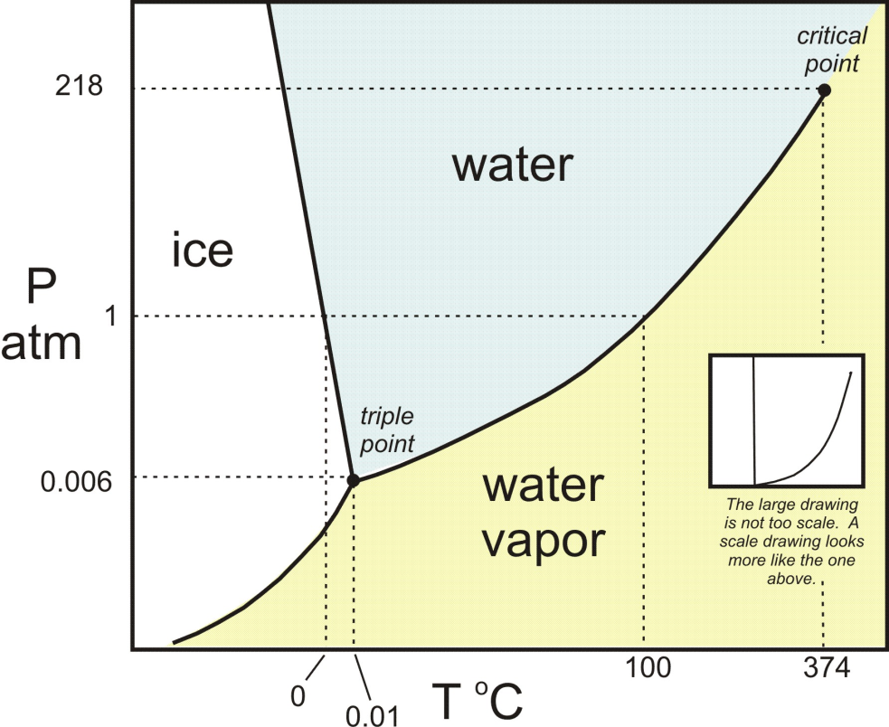
F
E
3
2
1
D
C
B
A

- What is the critical pressure and critical temperature for water?
- What does the triple point represent?
- What point corresponds to where sublimation can occur?
- What point represents the liquid phase?
- What point is the normal boiling point? ...normal freezing point?
- What point(s) would only L and G be in equilibrium?
- Where would the solid phase exist?

- What is the relationship between vapor pressure of a substance and...

- temperature:

- strength of intermolecular forces:

- polarity of the substance:

- its boiling point:

- its “volatility”:

- How do the three states of matter: S, L, and G differ from one another at the molecular and macroscopic levels?

- What is kinetic theory? What are its assumptions?

- Convert (use the conversion string):

- 12.37kPa to mmHg

- 67PSI to atm

- If 56.0g of H₂O at a temperature of -45ºC is heated to a final temperature of 89.0ºC, how many joules of energy were absorbed by the water?

- Examine the vapor pressure diagram below...

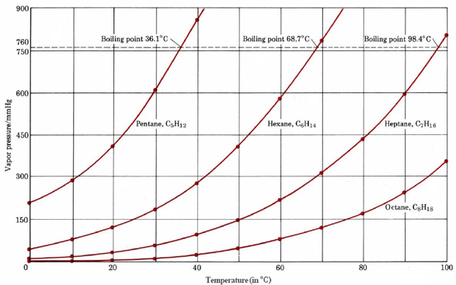
- How does size (molecular weight) of the molecule affect its vapor pressure? Why?
- Which substance has the highest intermolecular attractions (they are all non polar molecules)?
- What is the bp of hexane at a pressure of 170mmHg?
- How do changes in pressure affect bp of a substance, in terms of same or opposite?
- What is the normal (1 atm) bp of heptane?
- Which substance is most volatile (look up the definition of volatile)?

