Name: _____________________________________________ Period: __________ Date: __________________
INVESTIGATION OF A CANDLE
Question:
What is needed for a candle to burn?

Procedure:
- Measure the mass of the candle to the nearest 0.1g: _______________________
- Light the candle and allow it to burn for 3-4 minutes
- Extinguish the candle and measure its mass again: _________________________

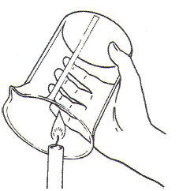
- Re-light the candle and place a large beaker over top of the candle, as shown at right. Observe what occurs to the flame after several minutes. Record these observations:

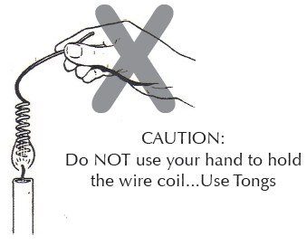
- Re-light the candle. Move a coiled metal wire into and out of the candle flame several times, without touching the wick. Observe what happens to the flame. Record these observations:

Claim(s):

Evidence and Reasoning:

Question:
What is produced as a candle burns?

Procedure:
- Place a drop of water on a piece of cobalt chloride paper. Record your observations:

- Observe teacher demonstration with cobalt chloride paper. Record these observations:

- Re-light the candle. Collect a sample of vapor from the candle flame by holding a small Erlenmeyer flask over the flame for about 30 seconds. Place a rubber stopper in the opening of the flask to seal the vapors inside. Add a few mL of limewater to this flask, re-stopper, and swirl. Record your observations:

- Using the internet, find out what substance makes lime water change in appearance (cite your source) :

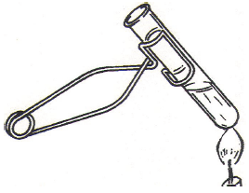
- Fill a large test about half-full of tap water.
- Measure the temperature of the water to the nearest 0.1ºC: ____________________
- Using a test tube holder, as shown at right, begin heating the water in the test tube
- After 1-2 minutes, measure the temperature of the water to the nearest 0.1ºC:

__________________

Claim(s):

Evidence and Reasoning:

Extend: Find definitions for the words quantitative and qualitative. How do these terms relate to the measurements and observations made in this lab?

