Answers to Page 78 1-5
- Columns, groups, or families have the similar physical and chemical properties.
- The steps separate the metals and the non-metals. Note that all of the metalloids are near the stair steps.
- Hydrogen H₂, Nitrogen N₂, Oxygen O₂, Fluorine F₂, Chlorine Cl₂, Bromine Br₂, and Iodine I₂. These are the “silly seven”.
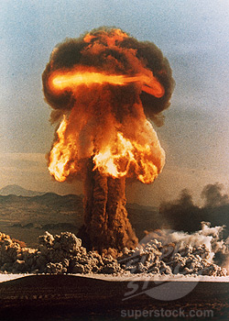
- Hydrogen H₂, Nitrogen N₂, Oxygen O₂, Fluorine F₂, Chlorine Cl_{2,} Helium He, Neon Ne, Argon Ar, Krypton Kr, Xenon Xe, and Radon Rn.
- Electrons are added or subtracted. NEVER CHANGE THE PROTONS!!! OR =============================

Fluorine gains and electron F + e⁻ -> F⁻
Lithium loses an electron Li -> Li⁺ +e⁻

